Team 4322
PHI Omega

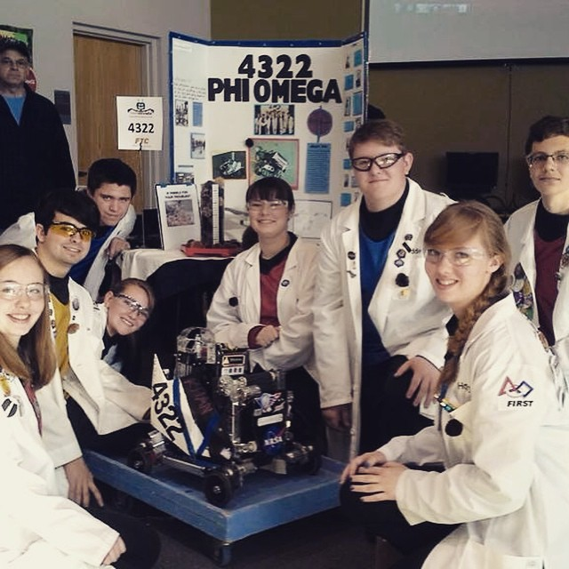

Colossians 3:17
Strategy:
Autonomy:
We have two autonomies:
(1) Ramp Autonomous-
1. Drives off ramp
2. Grabs onto medium rolling goal
3. Brings rolling goal into parking-zone
4. Scores ball into rolling goal
(2) Parking-Zone Autonomous-
1. Grabs small rolling goal
2. Brings rolling goal into parking-zone
3. Scores ball into rolling goal
Teleop:
Our driving strategy is to get the small and medium goals on the ramp, leaving the tallest rolling goal on the floor. We then knock out the kickstand (if it’s not already knocked out), and score in the tall goal. Once end-game starts, we score in the center goal. If enough time is left, we park on the ramp.

Khan
Khan was built from the inside-out. Some of his special features include:
- Suspension
- Carbon-fiber shields
- Chain drive
- 1-1 gear ratio for his winch
- Three stage slider-arm
- Hooks to grab rolling goals
- Conveyor belt intake-system
- Multi-plexar sensor
- LED lights
- Ultra-sonic sensor
- Touch sensor
- Light sensor
- Accelerometer
- Gyro sensor
- Integrating acceleration to get distance
- Stick-shaping during Teleop


Team Info

PHI Omega is a 501(c)(3) non-profit organization. We are a Christian home-schooled/private-schooled team. We are from Lancaster, CA. Our robot’s name is Khan.

Team Members:
Jonathan: Hardware, fourth year
Noah: Software, second year
Eddie: Hardware/Software, third year
Kaitlin: Notebook, third year
Holly: Notebook, first year
Hanna: Hardware, first year
Becky: Software, first year
Sergei: Hardware, first year

